User Guide
For use of OpenLP, Amplification and Creche
at Wincanton Baptist Church
Table of Contents
Introduction 1
Powering Up 2
Powering Down 3
Amplification 4
CD Player 6
Laptop 7
Creating a new service 8
Loading items into the service 8
Loading songs 8
Loading bible readings 9
Loading presentations 10
Loading Images 10
Loading media 10
Ordering the service 11
Saving the service 11
Loading an existing service 11
Running the service 12
Presentation Remote 13
Creche 14
Appendix A – Amplification 15
Input Channels 15
Output Channels 16
Other Equipment 17
Microphone Batteries 17
Appendix B – OpenLP 18
Adding New Songs 18
Editing Existing Songs 19
Adding Presentations 19
Adding Images 20
Adding Media Clips 20

Introduction
This is intended to be a basic guide for using the ‘back of the church’ equipment, it is not intended to be comprehensive or complete, but to cover the basic essentials needed to provide the normal operation during a service.

Powering Up
Turn on at the wall:
- Mixing Desk / Amplifiers / Laptop
  - Two switches at the back by the mixer/laptop
  - On the laptop open the display and press the button in the top left.
- Radio Microphones
  - Turn on each radio microphone being used
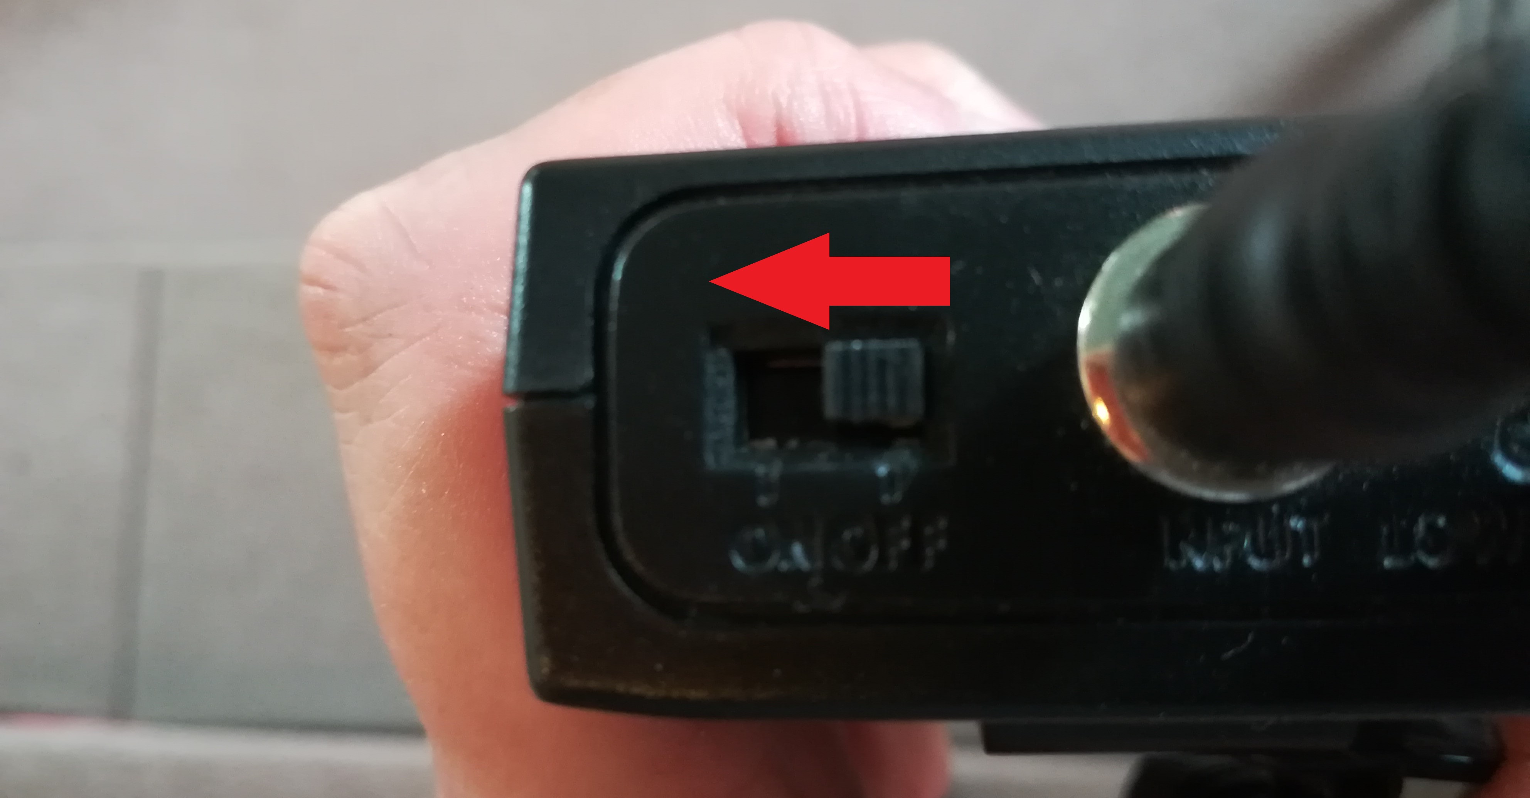
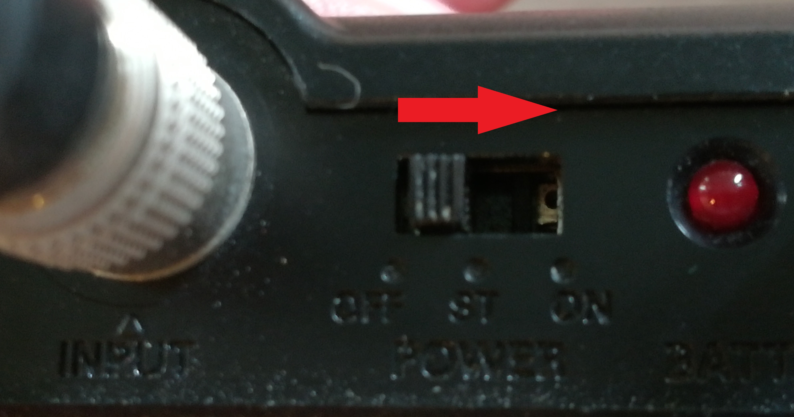
    - The two clip on microphones are switched on by moving the switch to the side as indicated below.
    - The LED on the UHF microphone (pictured above left) will flash on then off. If it stays on the battery is low.
    - The LED on the VHF microphone (pictured above right) will stay on while the battery is OK.
    - The handheld microphones are switched on by moving the switch(es) as indicated below.
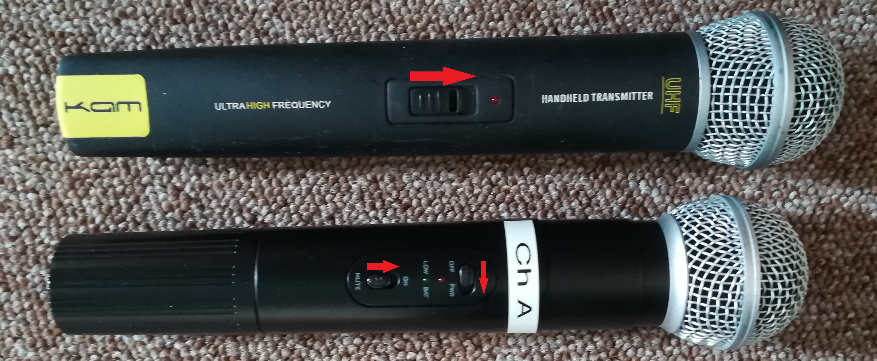
    - The LED on the notice & spare #2 microphone will flash on then off. If it stays on the battery is low.
    - The red LED on the spare A & B microphones will be on when powered with the green LED indicating low battery.
- Displays
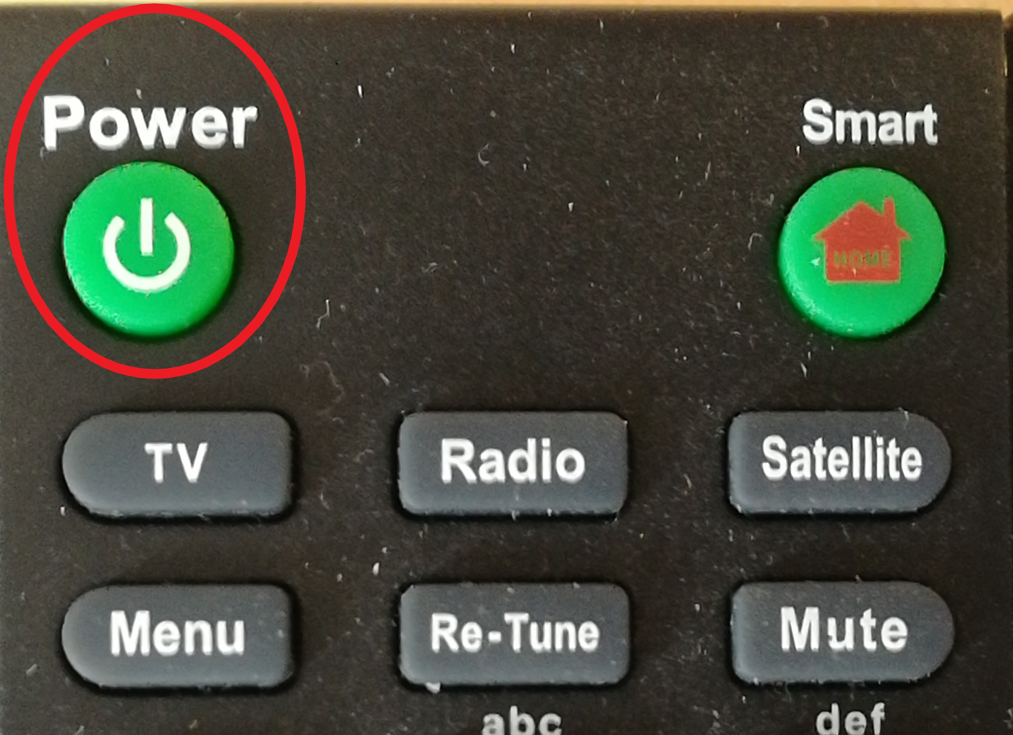
  - One switch on the side wall below each display
  - Use the remote to turn each display on
- Creche
  - Turn on the equipment at the wall under the amplifier in the creche. See Creche section below for sending the sound to the creche system

Powering Down
Powering down at the end of the meeting is a lot easier.
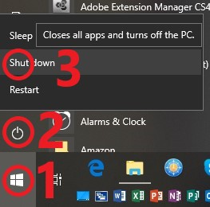
- Turn off the laptop by exiting the exiting any programs and shutting down
  - Exit all programs either by clicking the red X in the top right corner or using the File | Exit menu option.
  - Shutdown the laptop by:
    - Selecting the Start Menu
    - Selecting the Power button
    - Selecting Shut down
    - Once the laptop has shut down close the display
- Turn off all the wall switches turned on when powering up the equipment
- Turn off the radio microphones
- Don’t forget the creche if it was used

Amplification
The individual equipment is not turned on/off, but always left turned on. The amplifier is set to a level that should avoid feedback in all normal use conditions and should not be touched.
The mixing desk takes up to 16 inputs and provides outputs to:
- amplifier to drive the speakers in the church
- creche
- recording device (not covered by this guide)
- fold back of keyboard/vocals for music group
As can be seen from the picture below, the mixer consists of a number of input channels (1-16) on the left and 3 output channels on the right (L/R/Mono).
The input channels are all the same and are setup to prevent feedback under usual conditions, as such the only adjustments needed is moving the slider at the bottom of the input channels to increase or lower the volume of the input.
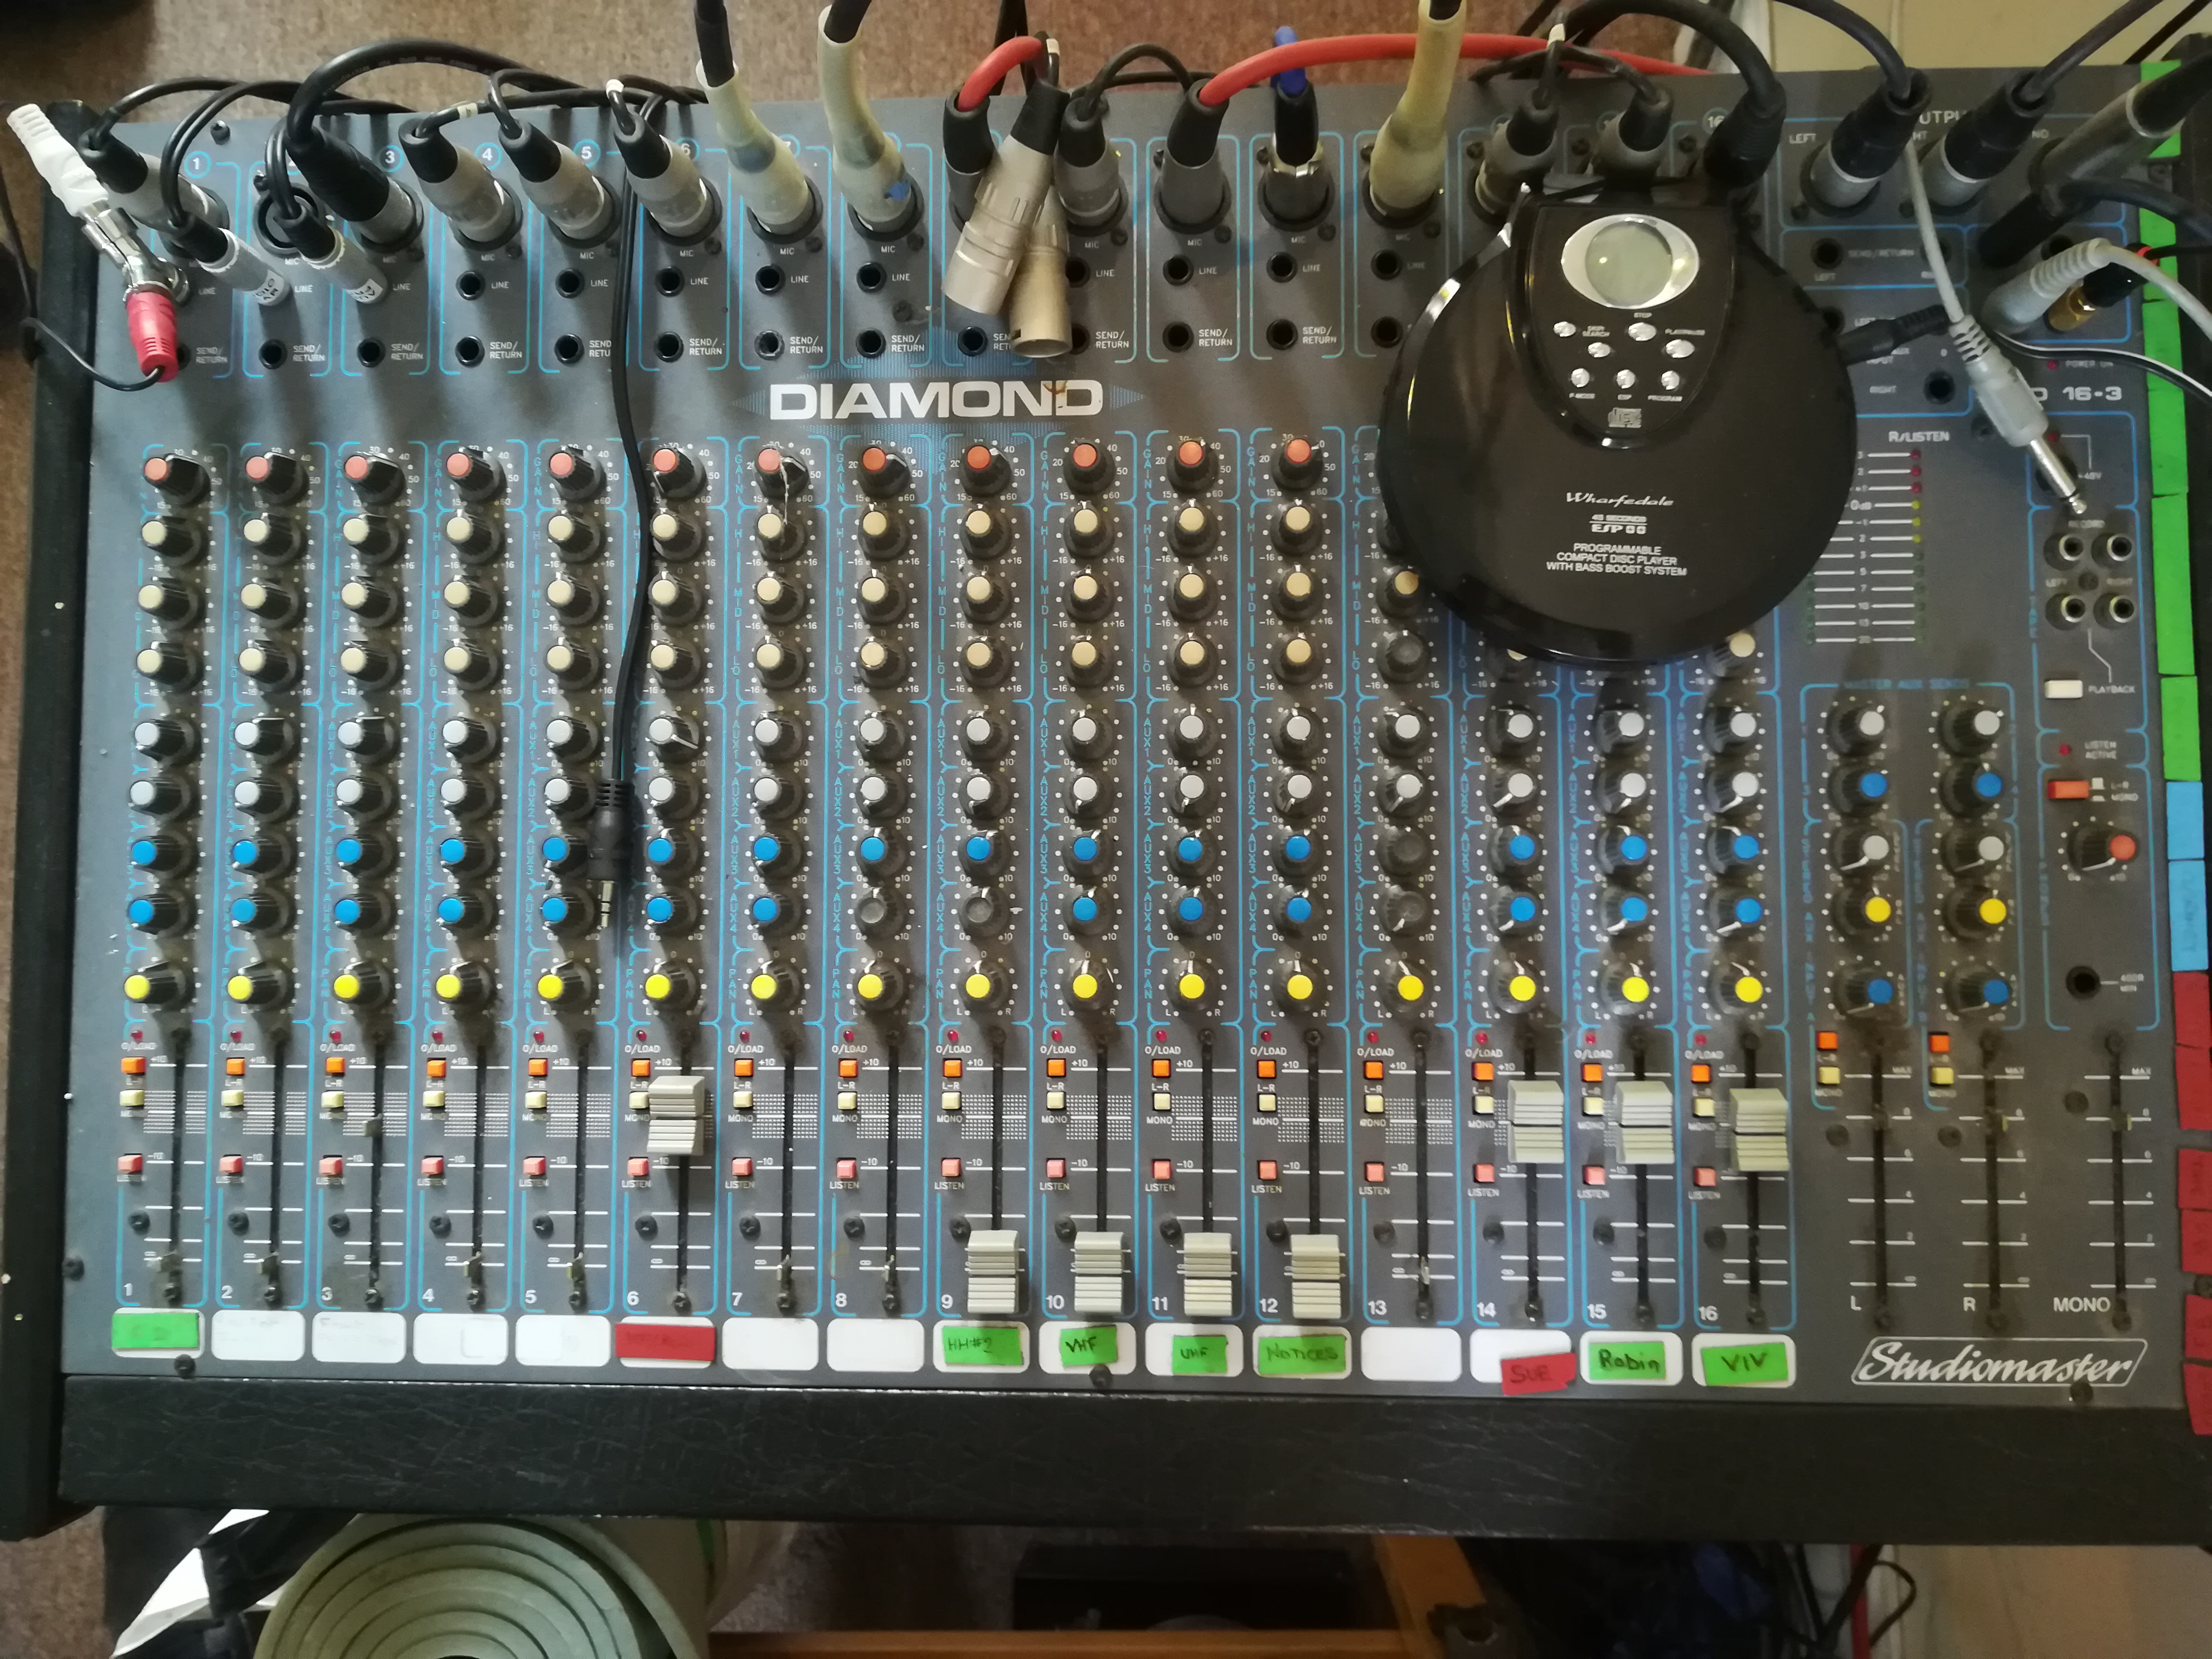
Adjusting any of the other knobs or switches may prevent normal operation
The three output sliders are left on the ‘0dB’ setting, one line down from the maximum.
Channel usage:
- Local CD player, can be used with any 1/8” stereo output, plug can be seen in the above picture between the 5 and 6 channels.
- Front audio connector
- Laptop audio
- Not Used
- Not Used
- Keyboard
- Spare radio microphone A
- Spare radio microphone B
- Spare radio microphone #2
- Spare clip on radio microphone (VHF)
- Main clip on radio microphone (UHF)
- Notices radio microphone
- Not Used
- Music group – Sue
- Music group – Robin
- Music group – Viv
The music group volume sliders are left on the 0dB setting.
The other radio microphone volumes are adjusted as needed during the service, it is good practice to reduce the level of them during congregational singing.
More details of the settings can be found in the appendices of this guide.

CD Player
Normally the CD player is only needed to play a single track, if more tracks are required then these instructions provide the basic controls needed.
- Open the CD player by sliding the switch on the front edge, this will pop-up the lid and allow the CD to be inserted.
- Close the lid.
- At this point the player should spin up the CD and work out how many tracks there are.
- Once this is done press the ‘Play/Pause’ button and ensure that sound is correctly heard from the sound system.
  - If no sound is heard then check that the 1/8” plug is plugged into the line output of the player not the headphones socket.
  - Check that the volume slider on channel 1 is moved up to allow the sound into the system.
- Once happy that sound is coming out, press the ‘Play/Pause’ button.
- Now using the ‘Skip/Search’ buttons move to the track that is to be played, as the player is in pause mode it will not play the track but cue it up at the start.
- When it needs to be played press the ‘Play/Pause’ button.
- When finished press the ‘Stop’ button.

Laptop
In normal use the only program that needs to be run is OpenLP. This is an open source program that is designed to put words, presentations, videos etc onto display for church use.

Run the program by double clicking the icon -
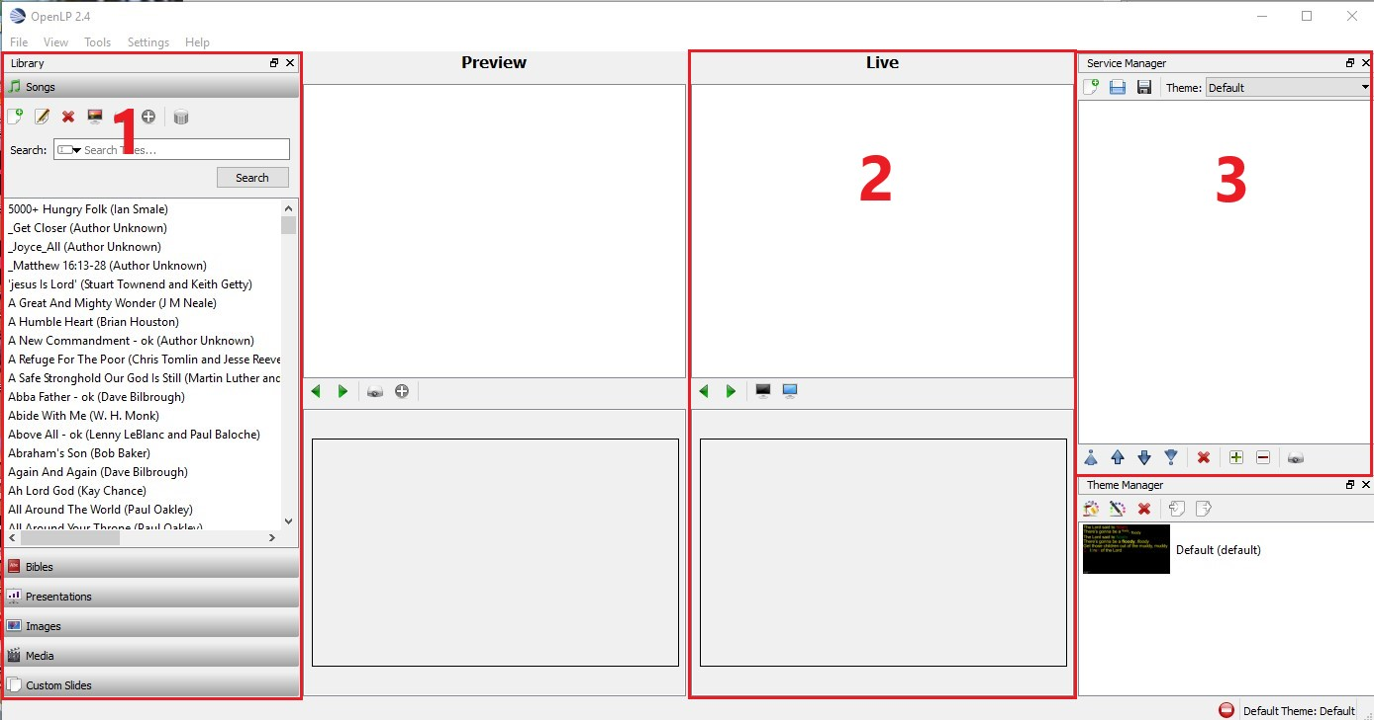
This will display the main screen in full screen mode and will look something like this -
The areas of interest are numbered:
- This area contains the items that have already been imported into OpenLP and can be used as part of the service. More details on how these are imported can be found in the appedixes of this guide.
- This is the ‘Live’ display and shows what is either being displayed on the screens or will be if they are unblanked.
- This area contains the items in the current service.

Creating a new service

Loading items into the service
The library section (1 above) holds all the items which can be used in the service. Adding them to a service is very similar for each type. How to add items to the library is covered in the appendices.

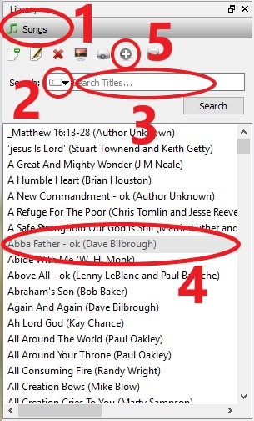
Loading songs
To locate and insert the songs into the service:
- Click on the ‘Songs’ banner in section 1 to expand the available list of songs.
- Clicking on the little black arrow in the Search box will allow the selection of what to search. Generally this will be left as ‘Titles’, however, it may need to be changed to ‘Entire Song’ if it is not found using the title search.
- In the text area, where it has Search Titles…, enter the title of the song being searched, this will reduce the songs listed and allow the correct song to be selected.
- Generally, all songs we use regularly will have their title followed by ‘- ok’ to indicate that the words have been checked. Select the song by single clicking on it.
- Click the ‘+’ symbol to add the song to the service, it will now appear in the list in section 3.
- Repeat 3 – 5 for each song required.

Loading bible readings
To add bible readings to the service:
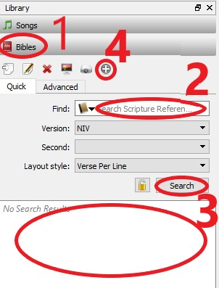
- Click on the ‘Bibles’ banner in section 1 to expand the bibles section.
- On the quick tab type the bible reference. It understands most common methods of specifying bible references, so the following will work:
  - Book Chapter
  - Book Chapter-Chapter
  - Book Chapter:Verse-Verse
  - Book Chapter:Verse-Verse,Verse-Verse
  - Book Chapter:Verse-Verse,Chapter:Verse-Verse
  - Book Chapter:Verse-Chapter:Verse
- On pressing the ‘Enter’ key or the ‘Search’ button the selection passage should be shown in the search results section.
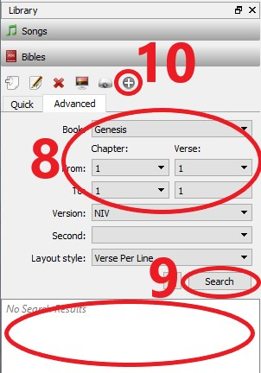
- Click the ‘+’ symbol to add the bible reading to the service, it will now appear in the list in section 3.
- Repeat 2-4 for any other readings required.
- Alternatively, the Advanced tab can be used.
- Here the selections are made using the drop down option boxes:
- Click in each of the boxes and select the appropriate values for the reading.
  - Book
  - From Chapter and Verse
  - To Chapter and Verse
- Clicking the ‘Search’ button will show the selected reading in the search results section.
- Click the ‘+’ symbol to add the bible reading to the service, it will not appear in the list in section 3.
- Repeat 8-10 for any other readings.

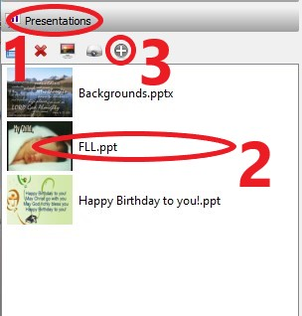
Loading presentations
To add presentations to the service:
- Click on the ‘Presentations’ banner in section 1 to expand the presentations section.
- Select the presentation to be added to the service by single clicking on it.
- Click the ‘+’ symbol to add the presentation to the service, it will now appear in the list in section 3.
- Repeat 2-3 for any other presentations.

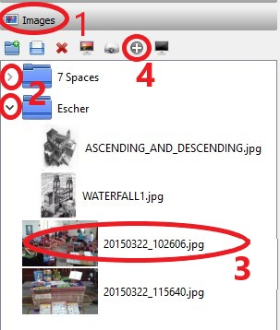

Loading Images
To add images to the service:
- Click on the ‘Images’ banner in section 1 to expand the image section.
- The images can be grouped together, to expand or close a group lick on the arrow.
- Select the image to be added to the service by single clicking on it.
- Click the ‘+’ symbol to add the presentation to the service, it will now appear in the list in section 3.
- Repeat 2-4 for any other images.

Loading media
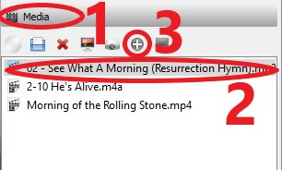
To add videos or music to the service:
- Click on the ‘Media’ banner in section 1 to expand the media section.
- Select the media to be added to the service by single clicking on it.
- Click the ‘+’ symbol to add the presentation to the service, it will now appear in the list in section 3.
- Repeat 2-3 for any other presentations.

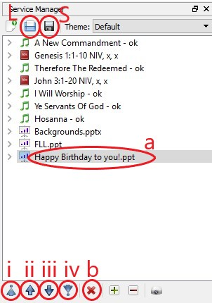
Ordering the service
To adjust the items in the service:
- Looking at the Service Manager, section 3.
- To move an item within the service:
  - Select the item to move by single clicking it.
  - Press the up/down arrows to move the item within the service order..
    - Move to top of the service
    - Move up one position
    - Move down one position
    - Move to bottom of the service
- To remove an item from the service:
  - Select the item to remove by single clicking it.
  - Press the red ‘X’ button.

Saving the service
Each service is saved to allow reporting of the song usage and to allow easy reload if something happens to the laptop. To save the service, in the Service Manager, section 3:
- Click on the black disk icon (S above)
- This will bring up a normal save dialog with the save name already populated. The file name is in the form of ‘Service YYYY-MM-DD HH-MM.osz’ and should not be changed. The location is the documents folder
They should not be moved to the year folder until the details have been entered on the CCLI license website.
- Click the ‘Save’ button.

Loading an existing service
To load an already saved service order, in the Service Manager, section 3:
- Click on the blue disk icon (L above)
- This will bring up a normal open file dialog.
- Select the file to load.
- Click the ‘Open’ button.

Running the service
With a service order loaded the Service Manager will list all the items.
To display items they are sent to the Live display portion of the screen, which shows what is displayed on the monitors or will be displayed if they are unblanked.
Double clicking an item in the Service Manager will send it to the Live display, or select the item with a single click and press the ‘Send to Live’ button in the bottom right of the Service Manager area.
The buttons in the middle of the Live display control how the screen is blanked, these can vary depending on what is being shown. The display is blanked if the button is highlighted.
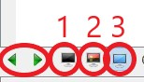
- Blank Screen
- Theme Background
- Desktop Background (currently selected in the image)
The two arrows allow moving forwards and backwards through the item, e.g. move verses.
If the item being displayed does not have a theme, video, presentation etc. then button 2 will not be displayed.
To avoid confusion it is probably best to only used the Blank Screen button (1). This can then be toggled on/off to show/hide the item on display.
The service can be controlled completely by the mouse or keyboard. Keyboard shortcuts will be shown along with the mouse usage in brackets and quotes i.e. (‘.’) or (‘Up Arrow’).
The starting point would be with the service loaded and no items selected for display (the Live display is blank).
- Blank the displays by clicking the Blank Screen button on the Live Display (‘.’)
- Double click the item to be sent to the display.
- The section being displayed will be highlighted.
- Use the mouse to click on the section to be displayed if it is not highlighted (‘Up/Down Arrow’).
- Press the Blank Screen button on the Live display (‘.’) to show the item.
- To move to the next verse click on it with the mouse of press (‘Down Arrow’). Normally the songs will be in correct verse/chorus order and will run straight through from start to end.
- When the item has finished press the Blank Screen button on the Live display (‘.’) to blank the displays.
- Select the next item in preparation by double clicking it in the Service Manager (or ‘Left/Right Arrow’).
- Go to 3.
- Repeat until end of service.
This sequence will work for songs, readings and presentations.
Video and audio clips work in the same way except there is no moving between sections.
- Double clicking the media clip while the screen is blank will sent it to live but not start it
- Unblanking the displays starts the media clip.
- Blanking the displays again will pause the clip (probably not wanted unless only part of the clip is needed).

Presentation Remote
There is a presentation remote that can be used to move presentations forwards/backwards manually. This is useful for the leader to advance slides as they talk.
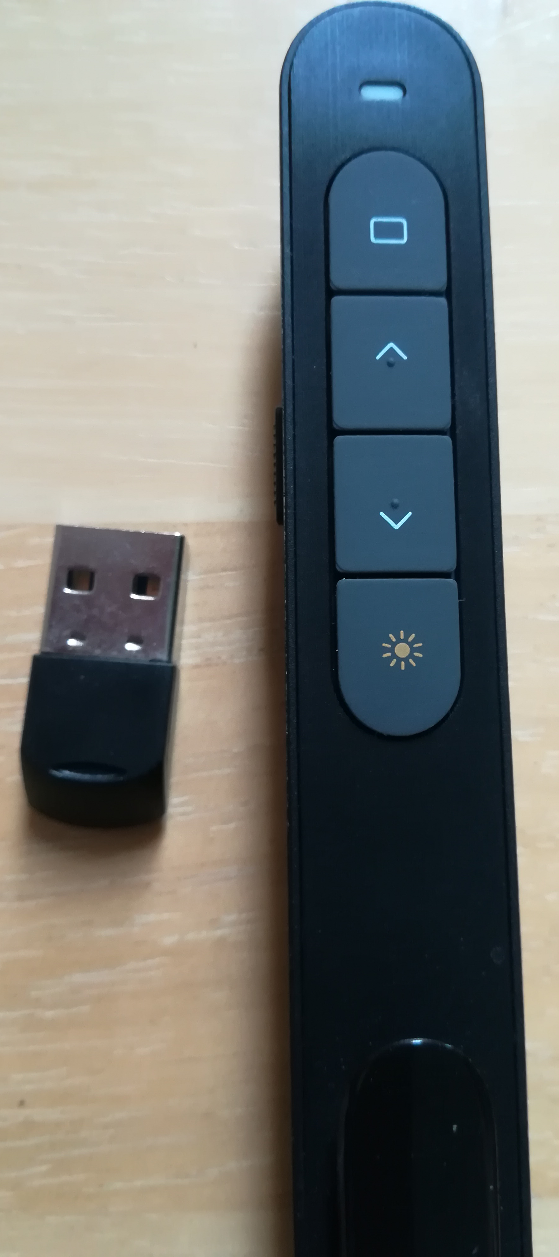
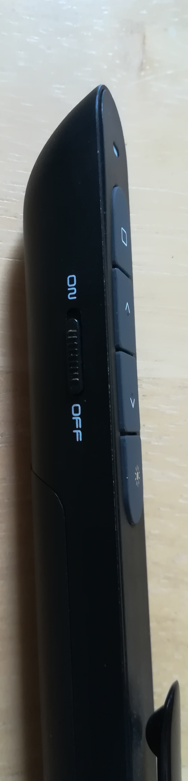
- The USB dongle is found in a slot in at the front of the remote. It should be extracted and inserted into one of the laptops USB sockets. There is one on the right side of the laptop.
- The remote is switched on/off by moving the slider on the left side of the remote.
- When the remote is going to be used the operator of the laptop will start the presentation as usual and un-blank the screen. It is essential that the ‘Live’ screen has focus for the remote to correctly work.
- On the remote the ‘v’ button moves the presentation forward and the ‘^’ button moves back.
- Switch off the remote when finished and return the USB dongle to the front slot.
For the remote to work properly the laptop operator must start the presentation and then NOT click anywhere else.

Creche
The sound for the creche is taken from the mixer post-fade channel 4. This allows just the main microphone signals to be sent to the creche and then only if the volume sliders are up.
To connect the mixer to the amplifier in the creche the Bluetooth Tx/Rx modules need to be turned on. The Tx module should be turned on first.
The modules look the same but with Tx or Rx on top.
Locate the Tx module by the mixer, probably in one of the chair book shelves.
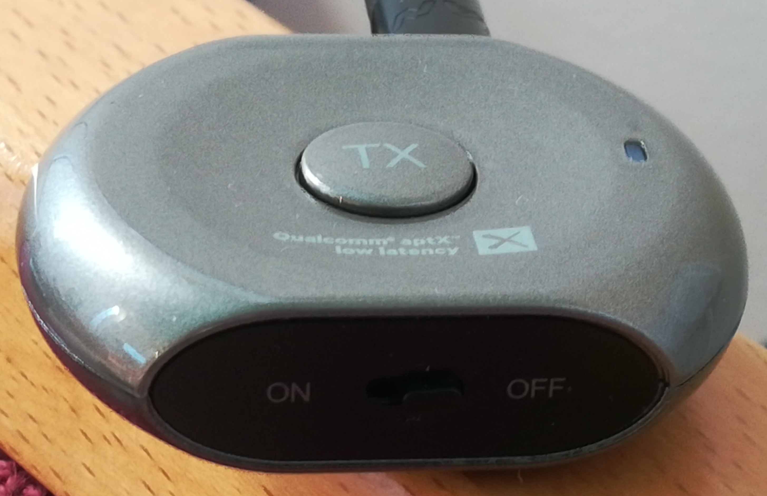
Slide the little switch on the front edge to the ON position.
In the creche with the amplifier already turned on, switch on the Rx module in the same way. An ascending series of tones will be heard and 30 seconds or so later ‘Connected’ this indicates that it is receiving from the Tx module.
At the end of the service turn off both modules.

Appendix A – Amplification

Input Channels
Each of the input channels consists of 3 sockets, 9 rotary knobs, 3 push buttons and a slider.
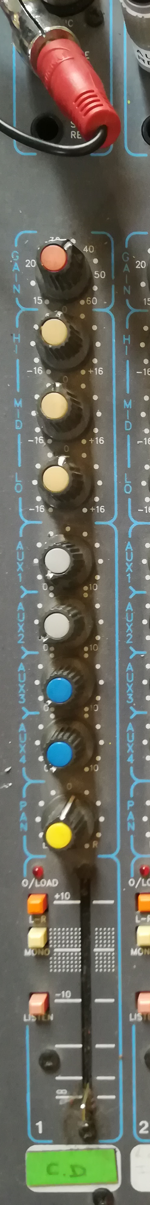
- The top socket is a standard XLR connection for a balanced microphone.
- The ‘Line’ input is a ¼ inch mono jack socket used for any other input.
- The Send/Return socket is a stereo ¼ inch socket that sends the signal out one connection and back the other to allow for various effects units to be plugged in.
- The top rotary knob controls the gain of the input signal, it is set to a level that gives a good clean volume when the slider is at its maximum setting. For radio microphones this is set to the point just before feedback occurs if the microphone is used near any of the loud speakers.
- The next 3 controls are for the shaping the frequency response, normally left in there neutral center position.
- The 4 auxiliary controls allow an amount of the signal to be sent to 4 extra outputs.
  - Aux 1 & 2 are post-fade sends, that is, the signal is taken after it has gone through the slider control, so if the slider is at the bottom (∞) no signal will be output.
    - Aux 1 is used to send a signal to the creche, Aux 2 is not used.
    - Input channels allocated to Aux 1: 7 – 12 radio microphone channels.
  - Aux 3 & 4 are pre-fade sends, that is, the signal is taken before it has gone though the slider control, so the position of the slider is irrelevant.
    - Aux 3 provides fold back to the music group, Aux 4 is not used.
    - Input channels allocated to Aux3: 6, 14 – 16 music group inputs
- The lowest rotary knob controls the position of the channel in the stereo field, as the church feeds both signal s to a single amplifier input, this should be left in the center position.
- The orange push button routes the channel to the main left/right outputs.
- The white push button routes the channel to the mono output.
- The red push button routes the channel to the listen channel (not used).
- The slider control limits the level being sent for that channel.

Output Channels
The mixer has 3 main output channels and 4 auxiliary send channels, these are controlled from the right side of the mixer.
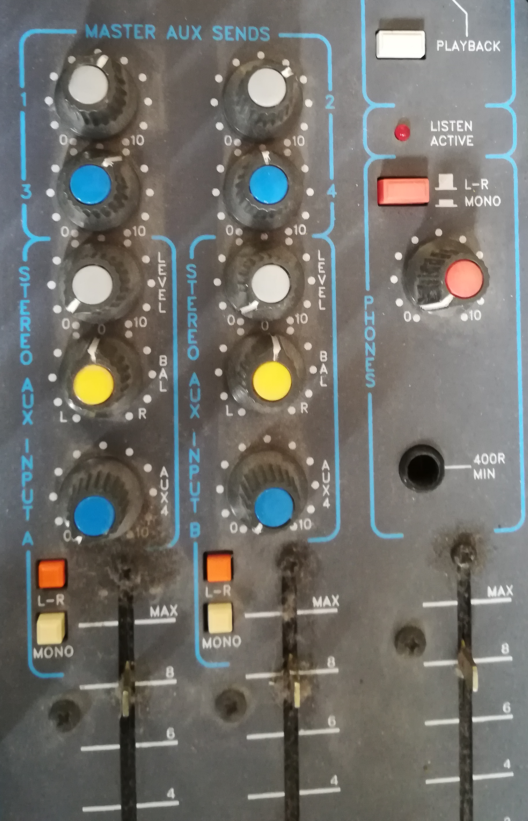
The three slider controls on the bottom right control the output of the left, right and mono channels. The left/right channels are connected to the a single input of the amplifier (located on the floor under the mixer).
The Master Aux Sends section provides control for the overall level of the signals sent out the auxiliary sends.

Other Equipment
The rest of the equipment associated with the amplification is located under the mixer. They consist of an amplifier to drive the loud speakers, and a number of radio microphone receivers.
As stated earlier all the individual equipment is left with their power switches in the on position and then all of them are turned on/off by the wall socket.
The output of the amplifier is sent to a wall box under the window that routes the signal to the loud speakers, the box has two ¼ inch mono jack sockets for left/right and a rotary switch. Normal use is for the switch to be in the mono position and the left socket with the amplifier output. This will route the signal to all loud speakers. It is possible to route separate signals to left/right by using both inputs and rotating the switch. The loud speakers will provide an 8Ω load.

Microphone Batteries
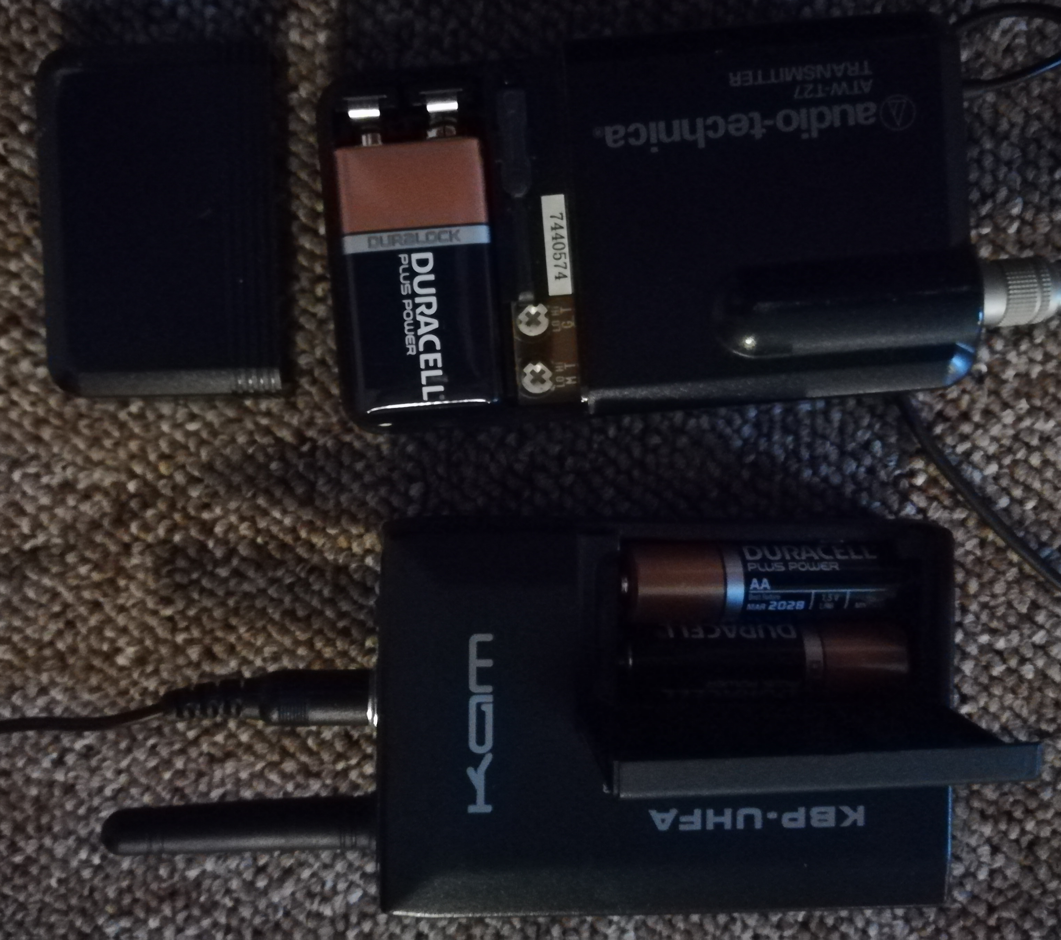
The radio microphones use either AA or PP3 9v batteries.
- Microphones using AA batteries:
  - UHF clip on.
  - UHF hand held.
- Microphones using PP3 9v batteries:
  - VHF clip on
  - VHF hand held
- To replace batteries:
  - Open cover.
  - Remove old batteries, they may be a tight fit and require the use of an implement to lever them apart.
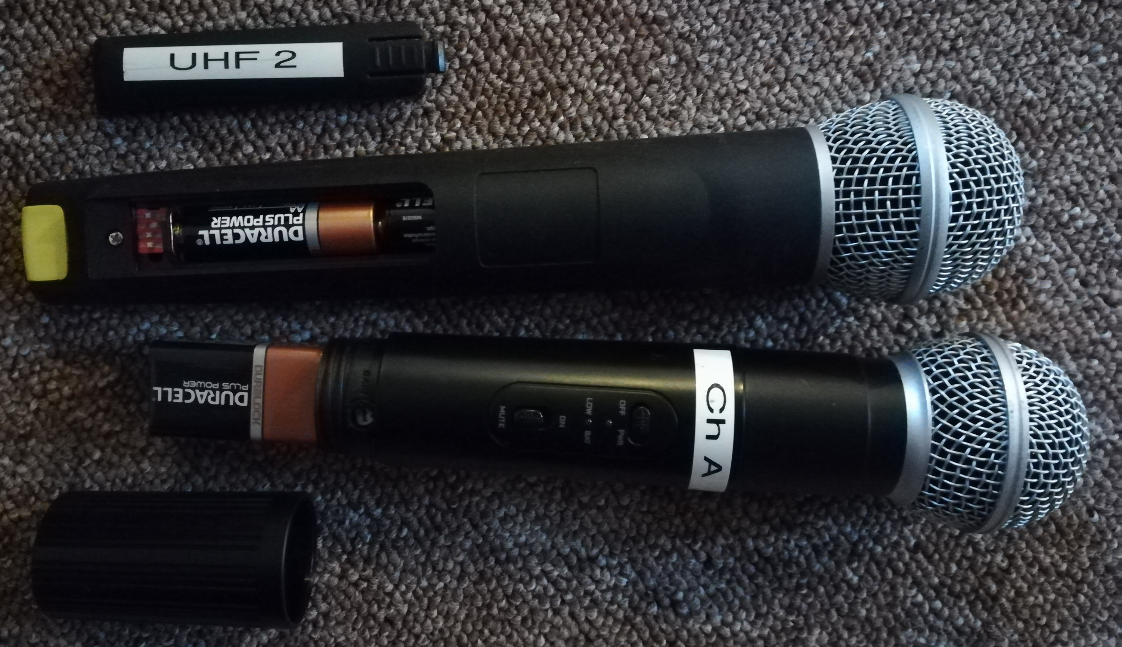
  - Insert new batteries.
  - Replace cover.

Appendix B – OpenLP
The main guide has shown how to create a service and operate the software to display the items as needed. This appendix will show how to get the items into the OpenLP software so they can be used in a service.

Adding New Songs
To add new songs to the database you can either type in all the words or copy and paste from an existing file e.g. text or word.
- If copying from an existing file open the file and select all the words and copy them into the paste buffer.
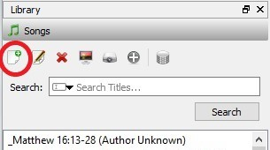
- In OpenLP open the Songs area and press the little document icon with the ‘+’ symbol on it.
- This will open the ‘Song Editor’ tabbed dialog.
- In the first tab ‘Title & Lyrics’
  - Enter the title and optionally an alternate title.
  - Press ‘Edit All’ to open the edit window, it will open with ---[Verse:1]---
  - Paste or type the words into the box
  - To add the verse/chorus breaks, put the cursor at the start of the line where the new verse or chorus starts and select the appropriate verse type and number and press the Insert button. The chorus only needs to be entered once.
  - To add optional breaks in individual verses use the Optional Split button.
  - Select OK once the words have been entered.
  - At the bottom of the window is a line for the verse order, whilst the program makes a good guess, it is better to enter them here, e.g.
V1 V2 V3 V4
V1 C1 V2 C1 V3 C1
V1 V2 C1 V3 V4 B1 C1
- Open the second tab ‘Authors, Topics & Songbooks’ as the words can’t be saved until author information is added.
  - Enter the name in the opt box under Authors, this is in first name second name order so for Keith Getty you need to enter Keith to locate him.
  - Select what part of the song they authored in the drop down box.
  - Press ‘Add to Song’ to add them to the song.
- Press ‘Save’ to save the words in the database.

Editing Existing Songs
To edit an existing song right-click on the song in any of the windows and select ‘Edit’ this will open the same ‘Song Editor’ as described above.
A single verse can be edited by selecting it and pressing ‘Edit’, this is good for correcting typos in the song.
The whole song can be edited by pressing ‘Edit All’ which opens ht same editor used to enter new songs, here typos can be corrected as well as the layout of verses etc.

Adding Presentations
To add a presentation to those available when creating a service
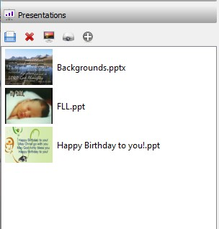
- Using normal windows operations copy the presentation(s) to the WBC user documents area. This can be accessed from the desktop icon. It is advisable to copy presentations so that in the event of any problems requiring a restart the service can be quickly recovered.
- In OpenLP open the Presentations area and press the blue disc icon.
- This will present the user with a standard open dialog box, navigate to the location of the new presentation and open it as usual.
- This will add the presentation to those already known, making it available for use in a service.
- Removing existing presentations can be done by single clicking the presentation and pressing the red cross. Note: This does NOT delete the presentation from the laptop so it can be added again in the future if needed. Doing this can reduce the clutter in this section.

Adding Images
To add images to those available when creating a service, images can be put into groups
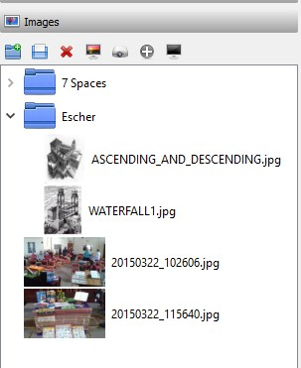
- Using normal windows operations copy the images to the WBC user ‘Pictures’ folder.
- In OpenLP open the Images area and press the blue disc icon.
- This will present the user with a standard open dialog box, navigate to the location of the new image and open it as usual.
- This will add the image to those already known, making them available for use in a service.
- Groups can be made for the images by pressing the blue folder icon. In the dialog that appears enter the new group name and select the parent group or top level group as needed.
- Groups can be expanded/closed by pressing the little arrow next to them.
- Removing existing images can be done by single clicking the image and pressing the red cross. Note: This does NOT delete the image from the laptop so it can be added again in the future if needed. Doing this can reduce the clutter in this section.

Adding Media Clips
To add media clips to those available when creating a service
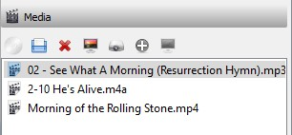
- Using normal windows operations copy the media to the WBC user ‘Videos’ or ‘Music’ folder.
- In OpenLP open the Media area and press the blue disc icon.
- This will present the user with a standard open dialog box, navigate to the location of the new image and open it as usual.
- This will add the media to those already known, making them available for use in a service.
- Removing existing media can be done by single clicking the media and pressing the red cross. Note: This does NOT delete the media from the laptop so it can be added again in the future if needed. Doing this can reduce the clutter in this section.

